Regulatory Committee
Meeting to be held on 23rd June 2021

Part I

Electoral Division affected:
Hoghton with Wheelton

Wildlife and Countryside Act 1981
Definitive Map Modification Order Investigation
Recording of Bridleway from Twist Moor Lane via Wood’s Fold Farm, Withnell to Bolton Road
(Annex ‘A’ refers)

Contact for further information quoting the reference number 804-648:
Simon Moore, 01772 531280, Paralegal Officer, County Secretary and Solicitors Group, Simon.Moore@lancashire.gov.uk
Jayne Elliott, 01772 537663, Public Rights of Way Definitive Map Officer, Planning and Environment Group, jayne.elliott@lancashire.gov.uk

Executive Summary

Application for the addition to the Definitive Map and Statement of a Bridleway and upgrade to Bridleway of Footpath Withnell 49 from Twist Moor Lane past Wood’s Fold Farm, Withnell to Bolton Road (A675).

Recommendation

That the above application be accepted in part subject to the status of

restricted byway between points A-F-G.

That an Order(s) be made pursuant to Section 53 (2)(b) and Section 53

(3)(c)(i) and (ii) of the Wildlife and Countryside Act 1981 to add a restricted byway and upgrade to restricted byway Footpath Withnell 49 from Twist Moor Lane past Wood’s Fold Farm, Withnell to A675 on the Definitive Map and Statement of Public Rights of Way as shown on Committee Plan between points A-B-C-D-E-F-G.

That being satisfied that the higher test for confirmation can be met the

Order(s) be promoted to confirmation.

Background

An application under Schedule 14 of the Wildlife and Countryside Act 1981 has been received for the addition of a Bridleway and upgrade to Bridleway of Footpath Withnell 49 from Twist Moor Road past Wood Folds Farm, Withnell to Bolton Road (A675) on the Definitive Map and Statement of Public Rights of Way.

The county council is required by law to investigate the evidence and make a decision based on that evidence as to whether a public right of way exists, and if so its status. Section 53(3)(b) and (c) of the Wildlife and Countryside Act 1981 set out the tests that need to be met when reaching a decision; also current Case Law needs to be applied.

An order will only be made to add a public right of way to the Definitive Map and Statement if the evidence shows that:
- A right of way “subsists” or is “reasonably alleged to subsist”

An order for upgrading or downgrading a way shown on the Definitive Map and Statement will only be made if the evidence shows that:
- "it ought to be there shown as a highway of a different description"

An order for adding a way to or upgrading a way shown on the Definitive Map and Statement will be made if the evidence shows that:
- “the expiration… of any period such that the enjoyment by the public…raises a presumption that the way has been dedicated as a public path or restricted byway”

When considering evidence, if it is shown that a highway existed then highway rights continue to exist (“once a highway, always a highway”) even if a route has since become disused or obstructed unless a legal order stopping up or diverting the rights has been made. Section 53 of the Wildlife and Countryside Act 1981 makes it clear that considerations such as suitability, the security of properties and the wishes of adjacent landowners cannot be considered. The Planning Inspectorate’s website also gives guidance about the interpretation of evidence.

The county council’s decision will be based on the interpretation of the evidence discovered by officers and documents and other evidence supplied by the applicant, landowners, consultees and other interested parties produced to the County Council before the date of the decision. Each piece of evidence will be tested and the evidence overall weighed on the balance of probabilities. It is possible that the council’s decision may be different from the status given in any original application. The decision may be that the routes have public rights as a footpath, bridleway, restricted byway or byway open to all traffic, or that no such right of way exists. The decision may also be that the routes to be added or deleted vary in length or location from those that were originally considered.

Consultations

Chorley Borough Council

Chorley Borough Council did not provide a response when consulted.

Withnell Parish Council

Withnell Parish Council did not provide a response when consulted.

Applicant/Landowners/Supporters/Objectors

The evidence submitted by the applicant/landowners/supporters/objectors and observations on those comments are included in Advice – Head of Service – Legal and Democratic Services Observations.

Advice

Head of Service – Planning and Environment

Points annotated on the attached Committee plan.

Point | Grid Reference (SD) | Description
A | 6406 2193 | Junction of Twist Moor Lane and Dole Lane
B | 6409 2190 | Unmarked point at the start of 9-3-FP 49 on Twist Moor Lane
C | 6428 2189 | Point at which 9-3-FP 49 leaves Twist Moor Lane at Wood’s Fold
D | 6435 2182 | Padlocked gate across route with adjacent gap
E | 6446 2177 | Junction of Twist Moor Lane with track
F | 6467 2143 | Point at which Twist Moor Lane splits as it rises uphill to meet the A675
G | 6469 2193 | Junction of Twist Moor Lane (south arm) with A675
H | 6467 2194 | Junction of Twist Moor Lane (north arm) with A675

Description of Route

A site inspection was carried out in January 2021.

The application route commences at a point on the 90 degree bend in the road at the junction of Twist Moor Lane and Dole Lane (Point A on the Committee plan). The route extends in a south easterly direction along a wide tarmac road for approximately 80 metres to the entrance to a quarry (now disused) at point B.

From point B the application route is recorded as Footpath Withnell 49 and continues in a generally easterly direction along a wide tarmac roadway rising gently uphill and bounded by buildings and fencing forming part of Wood’s Fold Timber Yard to the north and by the quarry and an area of woodland to the south.

Just before reaching point C there is access from the route into the timber yard and to a car park for customers visiting the site.

At point C Footpath Withnell 49 leaves the application route to continue north through the timber yard.

From point C the application route continues in a generally south easterly direction along a compacted stone surfaced track to point D where it is crossed by a padlocked gate. On the north side of the gate is a gap which restricts access to about 1.5m width and a clear earth and stone trod can be seen on the ground through this gap.

The route continues as a substantial compacted earth and stone surfaced track, bounded on both sides from adjacent land. It descends to cross a culverted watercourse and then ascends quite steeply passing through point E where a track leaves the route to continue south.

From point E the route continues in a north easterly direction downhill to point F to cross another culverted water course where it forks just before reaching the A675.The route splits with both tracks continuing for a short distance of approximately 20 metres each to rise uphill to meet the A675 at point G and point H. Padlocked gates have been erected across both parts of the route, apparently to prevent motorised vehicular use.

The total length of the route is approximately 760 metres.

Map and Documentary Evidence

A variety of maps, plans and other documents were examined to discover when the route came into being, and to try to determine what its status may be.

Document Title | Date | Brief Description of Document & Nature of Evidence
Yates’ Map  of Lancashire | 1786 | Small scale commercial map. Such maps were on sale to the public and hence to be of use to their customers the routes shown had to be available for the public to use. However, they were privately produced without a known system of consultation or checking. Limitations of scale also limited the routes that could be shown.
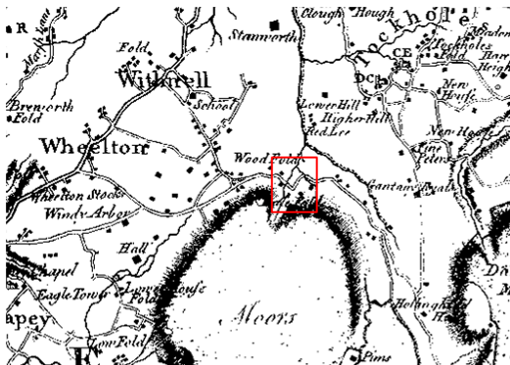
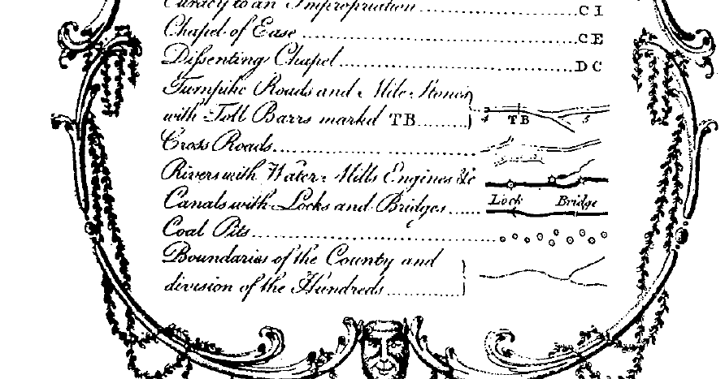
Observations |  | A route broadly consistent with the application route is shown on the map as a cross road passing a number of buildings in proximity to a property labelled as Wood Fold and crossing two watercourses. Dole Lane is not shown and the modern day A675 is not shown continuing north west from points G and H.
Investigating Officer's Comments |  | The application route appears to have existed in 1786 and is shown on the map as a cross road. It is not known what is meant by the term 'cross road' but the only other category of highway shown on the map is turnpike roads.  The inclusion of the route on such a small-scale map suggests that it existed as a substantial route and appears to have formed a through route as part of the general road network. The depiction of the route on this commercially produced small-scale map suggests that the route was considered to be a public highway and travellers using such a map were likely to be on horseback or horse-drawn vehicle.
Cary's Map of Lancashire | 1787 | John Cary was described as 'the most representative, able and prolific of English cartographers'. He was as busy a publisher as he was a cartographer and engraver, and until his death in 1835 published a constant flow of atlases, maps, road maps, canal plans, globes and geological surveys. He set new high standards of engraving and map design and in 1787 he published a 'New and Correct English Atlas' containing 46 maps which was re-issued ten times until 1831.  In 1794 the Postmaster General commissioned Cary to survey the main roads of Great Britain and his information on roads may be viewed with above average confidence.
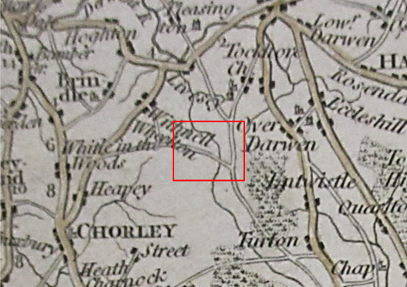
Observations |  | A route approximating to the application route is shown as part of a longer route which is shown passing through an area marked as Wheelton and continuing south east to Bolton Road.
Investigating Officer's Comments |  | The application route appears to be shown as part of a substantial route which would have been capable of being used on foot, horseback and with horse drawn vehicles in the late 1700s.
Greenwood’s Map of Lancashire | 1818 | Small scale commercial map. In contrast to other map makers of the era Greenwood stated in the legend that this map showed private as well as public roads and the two were not differentiated between within the key panel.
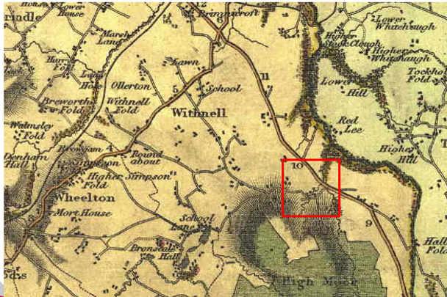

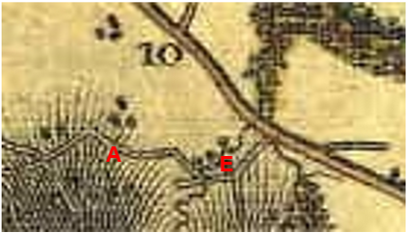
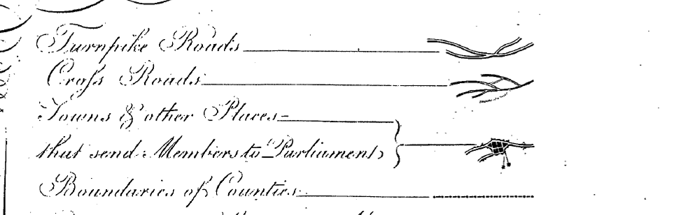
Observations |  | The application route is shown as part of the cross road linking through to Bolton Road (which is shown as a Turnpike Road) with a route extending south from it at the approximate location of point E. From point A a route can be seen going north east which stops after a short distance and which appears to be the first part of Dole Lane. The rest of Dole Lane is not shown.
Investigating Officer's Comments |  | The application route existed as a significant route in 1818 and appeared to be part of the public vehicular network at that time.
Hennet's Map of Lancashire | 1830 | Small scale commercial map. In 1830 Henry Teesdale of London published George Hennet's Map of Lancashire surveyed in 1828-1829 at a scale of 71/2 inches to 1 mile. Hennet's finer hachuring was no more successful than Greenwood's in portraying Lancashire's hills and valleys but his mapping of the county's communications network was generally considered to be the clearest and most helpful that had yet been achieved.
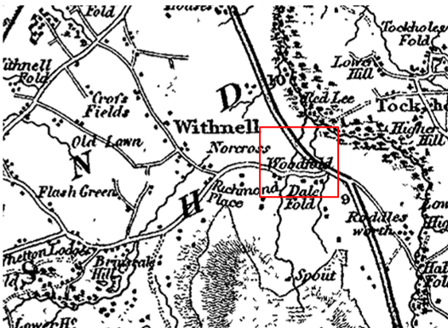
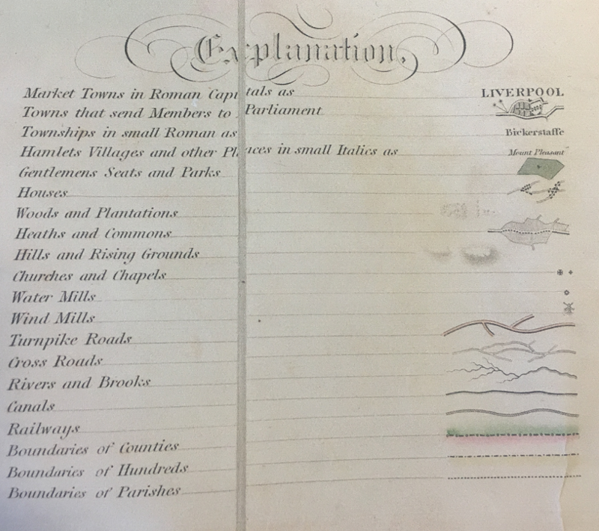
Observations |  | A route broadly consistent with the application route is again shown as a cross road passing Woodfold. Dole Lane is not shown.
Investigating Officer's Comments |  | The application route existed as a substantial route in 1830. The inclusion of the route on such a small-scale map suggests that it existed as a substantial route and appears to have formed part of a through route as part of the general road network. The depiction of the route on this commercially produced small-scale map suggests that the route was considered to be a public highway and travellers using such a map were likely to be on horseback or horse-drawn vehicle.  It is not fully known what is meant by the term ‘cross road’ but as the only other category of 'road' shown on the map are turnpike roads, it is possible that a cross road was regarded as either a public minor cart road or a bridleway (as suggested by the judge in Hollins v Oldham).  Hollins v Oldham Manchester High Court (1995) [C94/0205] Judge Howarth examined various maps from 1777-1830 including Greenwoods, Bryants and Burdetts. Maps of this type, which showed cross roads and turnpikes, were maps for the benefit of wealthy people and were very expensive. There was “no point showing a road to a purchaser if he did not have the right to use it.”
Canal and Railway Acts |  | Canals and railways were the vital infrastructure for a modernising economy and hence, like motorways and high-speed rail links today, legislation enabled these to be built by compulsion where agreement couldn't be reached. It was important to get the details right by making provision for any public rights of way to avoid objections but not to provide expensive crossings unless they really were public rights of way. This information is also often available for proposed canals and railways which were never built.
Observations |  | The land crossed by the application route is not affected by an existing canal or railway and there are no known proposals to have constructed either in the proximity of the route in the past.
Investigating Officer's Comments |  | No inference can be drawn with regards to the existence of public rights.
Tithe Map and Tithe Award or Apportionment | 1840 | Maps and other documents were produced under the Tithe Commutation Act of 1836 to record land capable of producing a crop and what each landowner should pay in lieu of tithes to the church. The maps are usually detailed large scale maps of a parish and while they were not produced specifically to show roads or public rights of way, the maps do show roads quite accurately and can provide useful supporting evidence (in conjunction with the written tithe award) and additional information from which the status of ways may be inferred.
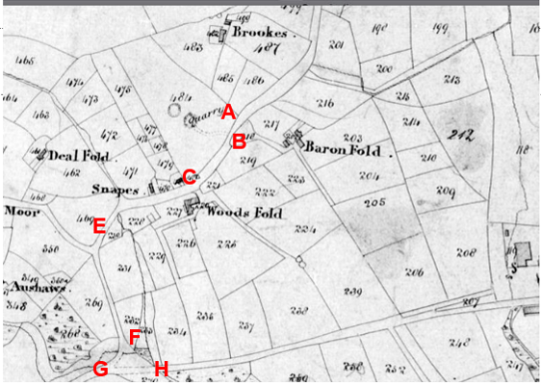
Observations |  | The full length of the application route is shown as part of a longer route which passes through point A and continues through to point F and point G. The route is not numbered on the map. Adjacent to point A access is shown to a property called Baron Fold but Dole Lane is not shown. At point B access is shown from the application route into a quarry. From point C the application route provides access to Woods Fold and several other properties are shown along the route or are accessed from the route. From point F the application route leads onto Bolton Road via point G with no access shown from point F to point H. No lines are shown across any part of the application route.  The Tithe Award does not include a list of routes considered to be public highways and although some roads shown on the map are numbered, they are all listed as being owned and are all referred to simply as ‘road’ with no Tithes payable.
Investigating Officer's Comments |  | The Tithe Map shows that the full length of the application route existed as part of a longer bounded through route in 1840 that would probably be wide enough for vehicles (carts) but not the spur F-H.  There are no lines shown across the route suggesting that it was not gated and that access was freely available along the full length. There is no key to the map however, and although lines are shown across some routes on the map it is not known for certain whether these lines indicated the existence of gates and whether all gates located on or across routes were shown.  The route is not numbered – in line with how other public vehicular routes are shown but it is accepted that this does not necessarily mean that it was because the road was public and there are other routes shown on the map recorded as roads which have no recorded public vehicular rights so the information provided by the Tithe Map and Award must be considered in the context of all other available evidence
Inclosure Act Award and Maps |  | Inclosure Awards are legal documents made under private acts of Parliament or general acts (post 1801) for reforming medieval farming practices, and also enabled new rights of way layouts in a parish to be made. They can provide conclusive evidence of status.
Observations |  | No inclosure award was found for the area crossed by the application route.
Investigating Officer's Comments |  | No inference can be made with regards to the existence of public rights.
6 Inch Ordnance Survey (OS) Map  Sheet LXX (70) | 1849 | The earliest Ordnance Survey 6 inch map for this area surveyed in 1845-1847 and published in 1849.
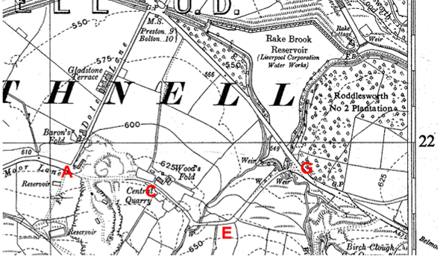
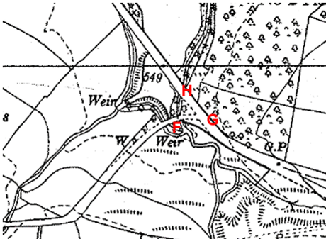
Observations |  | The full length of the application route is shown. Between point A and point C the route is shown bounded on either side by dashed lines indicating that it was not fenced from the adjacent land. It is shown passing through a quarried area to Wood’s Fold from where it continues bounded on either side by solid lines indicating that it was physically separated from the adjacent farmland passing through point F and point G. It appears to be of a substantial width consistent with how other routes now recorded as public vehicular highways are shown.  The route between point F and point H is not shown. The application route is not named on the map and it was noted that west of point A the road leading through to Brinscall was labelled as Twist Moor Lane and that from point A this road now continued north east to Bolton Road along the road named as Dole Lane.
Investigating Officer's Comments |  | The full length of the application route existed and appeared to be capable of being used in 1845-47. It is considered that a substantial bounded through route connecting to two other public vehicular highways would have been at least a public bridleway and may have carried public vehicular rights.  Earlier maps – including the Tithe Map produced only a few years earlier do not show Dole Lane or Gladstone Terrace and it appears that in the 5-7 years since the Tithe Map was prepared Dole Lane had been built which provided direct access from point A through to Bolton Road which was a turnpike road in the 1840s. This road is still in existence today and is the tarmac public vehicular route used by vehicles. It is straight, direct and less hilly than the application route which may account for its construction at that time.
Cassini Map Old Series  Blackburn and Burnley Sheet 103 | 1842-1859 | The Cassini publishing company produced maps based on Ordnance Survey mapping. These maps have been enlarged and reproduced to match the modern day 1:50,000 OS Landranger Maps and are readily available to purchase.
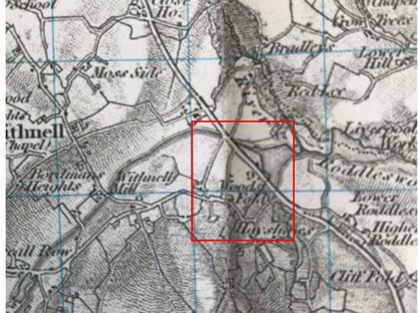

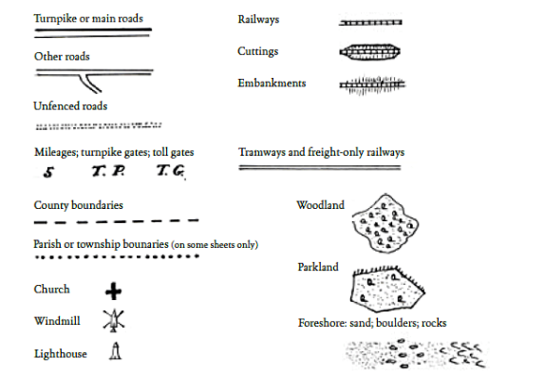
Legend source - http://www.cassinimaps.co.uk/shop/pagelegend.asp
Observations |  | The application route is shown as a through route past Wood’s Fold linking to other routes now recorded as public vehicular highways at either end.
Investigating Officer's Comments |  | The original scale of the map (1 inch to the mile) means that only the more significant routes are generally shown. The purpose of the map in the late 1800s would probably have been to assist the travelling public on horseback or vehicle suggesting that the through roads shown had public rights for those travellers.  No legends (map keys) existed on the original Old Series maps. Dr Richard Oliver (B.A., D.Phil., F.B.Cart.S.) notes that abbreviations and symbols were always employed but their usage, depiction and meaning evolved during the 70 plus years that it took to complete the old series mapping. Although a comprehensive legend is therefore impossible, some signs were (with minor variations) consistently used and these are shown on the map legend included above as found on the Cassini maps website and provided by Dr. Richard Oliver.  The application route appears, therefore, to be shown under the category of 'other roads' and its inclusion on this map suggests that it was available to be used on horseback and probably with vehicles at that time.
25 Inch OS Map  LXX.14 | 1894 | The earliest OS map at a scale of 25 inch to the mile. Surveyed in 1890-1891 and published in 1894.
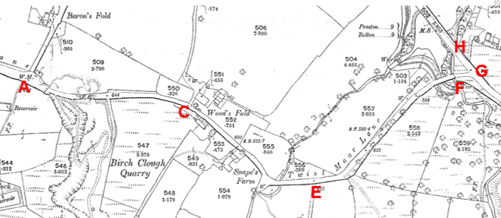
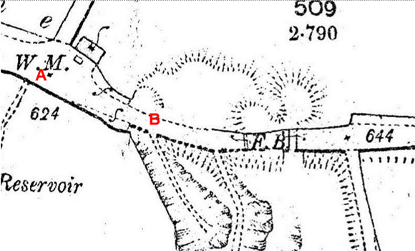
Observations |  | The full length of the application route is shown Passing through the quarried area and providing access to and past a number of named properties.  The route is named on the map as Twist Moor Lane, as is the continuation west from point A.  The full length of the route is shown with a thickened line along the south and east side indicating that at the time the route was surveyed it was considered to be a public road.  Point A is shown as a three way junction of routes all of which were shown with thickened lines suggesting the junction of three public vehicular routes.  The route between point A and point C passes through the middle of an area that was being quarried but the route itself appears to have remained intact. Footbridges are shown across the route just east of point B suggesting that the application route may have been at a different height than the quarry at this point.  Note the weighing machine (W.M.) on the road near the quarry.  Dashed lines are shown across the route at point F indicating a possible change in surface as the route approached the Turnpike Road. Access to the Turnpike Road is shown along the route between point F and point G but the route between point F and point H is not shown.
Investigating Officer's Comments |  | The full length of the application route existed in 1890-91 as a significant through route which passed right through the middle of a quarry. The fact that the route passed through the quarry and was not moved or absorbed into the quarry suggests its importance in the late 1800s and the fact that it was considered to be a public route which could not simply be quarried away.  Shading and thickening of lines was often used to show the administrative status of roads on 25 inch OS maps prepared between 1884 and 1912. The Ordnance Survey specified that all metalled public roads for wheeled traffic kept in good repair by the highway authority were to be shaded and shown with thickened lines on the south and east sides of the road. ‘Good repair’ meant that it should be possible to drive carriages and light carts over them at a trot so the fact that the route was shown in this way is consistent with how it was recorded on the Tithe Map and how it was shown on earlier small-scale commercial maps and indicated that the route was probably capable of being used on horses and is consistent with use of the route by the public at least on horseback at that time.  The fact that it was named as a road on the map is evidence that it was known locally by that name and is also consistent with use of the route by the public at least on horseback at that time.
1 inch OS  Sheet LXXV (75) - Preston | 1896 | Small-scale OS map.
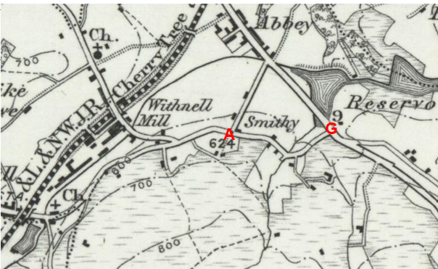
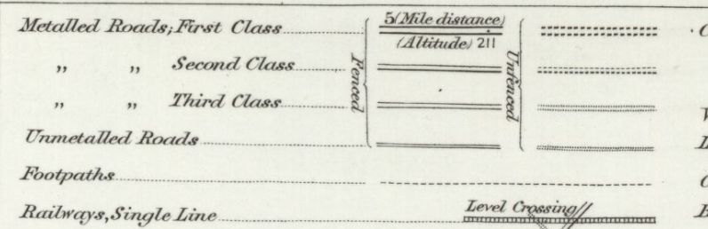
Observations |  | The full length of the application route, with the exception of F-H, is shown as a second class metalled road connecting to public vehicular routes at both ends and providing access to a number of properties located along it.
Investigating Officer’s Comments |  | The small-scale one inch OS map was predominantly published with the main market being the travelling public so the inclusion of the application route on this map is suggestive of a route that was capable of being used at least on horseback and more probably horse and carts.
Bacons Map of Lancashire | Circa 1905 | G W Bacon was a publisher of maps and in 1890 his 'Commercial and Library Map of Lancashire from the Ordnance Surveys' was published, and later reprinted. As the title states, the maps he published were derived from Ordnance Survey maps.
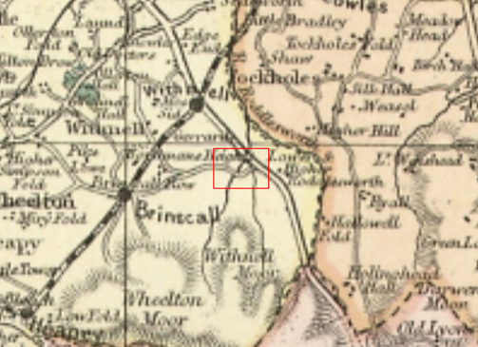
Observations |  | The application route is shown as part of a longer route passing through Brinscall. Dole Lane is not shown.
Investigating Officer's Comments |  | Bacon's maps of the British Isles were at a small scale and as such only the more significant routes are generally shown. Commercial maps of this nature were expensive to produce and to purchase and as a result routes shown were often considered to be public through routes. The application route is shown in the same way as routes now known to carry public vehicular rights supporting the fact that it existed as a substantial physical route at that time and that it was probably available for use by the public on horseback and possibly with vehicles.
Bartholomew half inch Mapping  Sheet 8 – Liverpool and Manchester | 1904 | The publication of Bartholomew's half inch maps for England and Wales began in 1897 and continued with periodic revisions until 1975. The maps were very popular with the public and sold in their millions, due largely to their accurate road classification and the use of layer colouring to depict contours. The maps were produced primarily for the purpose of driving and cycling and the firm was in competition with the Ordnance Survey, from whose maps Bartholomew's were reduced. An unpublished Ordnance Survey report dated 1914 acknowledged that the road classification on the OS small scale map was inferior to Bartholomew at that time for the use of motorists.
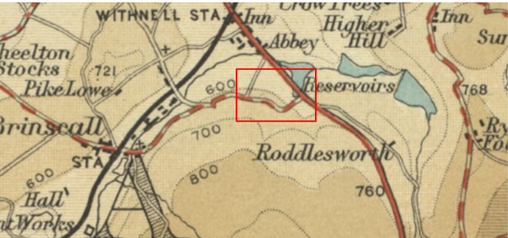
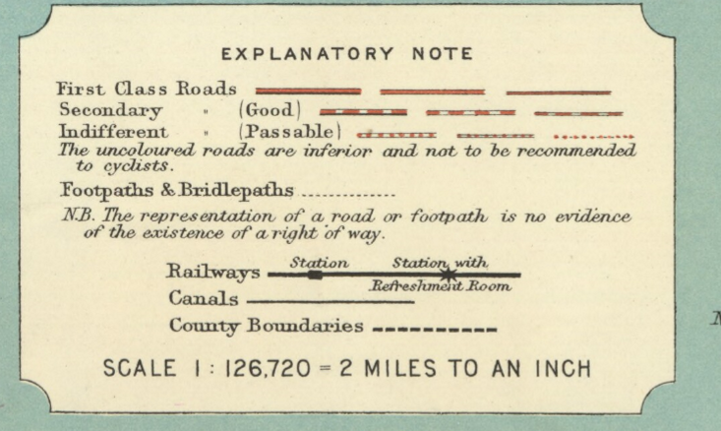

Observations |  | The application route is clearly shown on the map as a good second class road in contrast to Dole Lane which is shown as an uncoloured road said to be inferior and not recommended to cyclist.
Investigating Officer's Comments |  | The early 1900s saw a significant increase in the use of motorised vehicles and the classification of minor roads was constantly being reviewed by Bartholomew as some routes were improved to cope with increasing traffic whilst others were virtually abandoned and fell into disrepair.  Before1920, few roads other than main roads were tarred but the travelling public had lower expectations of surface conditions than today and it would not be uncommon for an unsealed road, at the time considered suitable for horse drawn vehicles or early motor cars, to be shown.  The application route is clearly shown on this map supporting the view that it physically existed in the early 1900s and is shown as a good secondary class road in preference to Dole Lane which is shown uncoloured.  The inclusion of the route on this map as a good secondary class road is evidence that the route was still considered to be a significant public vehicular route in the early 1900s.
Cassini Revised New Series Map  Blackburn and Burnley sheet 103 | 1903-1904 | An enlarged reprint of a map first published in 1903-1904 and based on OS 1 inch mapping.
goo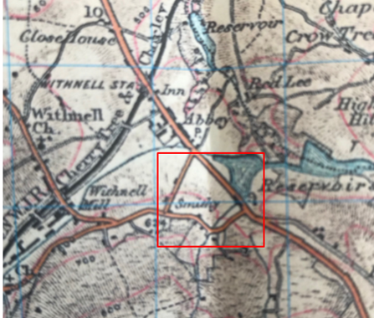
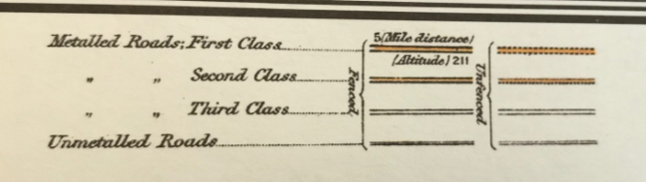
Observations |  | The application route is clearly shown on this small-scale map as a second class metalled road. Dole Lane is shown in the same way.
Investigating Officer's Comments |  | The route was again clearly shown as a second class public vehicular highway on a commercially produced small-scale map sold to the public suggesting not only that it existed but that it was capable of being used by the public and was considered to be a public vehicular route in 1903-1904.
Finance Act 1910 Map | 1910 | The comprehensive survey carried out for the Finance Act 1910, later repealed, was for the purposes of land valuation not recording public rights of way but can often provide very good evidence. Making a false claim for a deduction was an offence although a deduction did not have to be claimed so although there was a financial incentive a public right of way did not have to be admitted.  Maps, valuation books and field books produced under the requirements of the 1910 Finance Act have been examined. The Act required all land in private ownership to be recorded so that it could be valued and the owner taxed on any incremental value if the land was subsequently sold. The maps show land divided into parcels on which tax was levied, and accompanying valuation books provide details of the value of each parcel of land, along with the name of the owner and tenant (where applicable).  An owner of land could claim a reduction in tax if his land was crossed by a public right of way and this can be found in the relevant valuation book. However, the exact route of the right of way was not recorded in the book or on the accompanying map. Where only one path was shown by the Ordnance Survey through the landholding, it is likely that the path shown is the one referred to, but we cannot be certain. In the case where many paths are shown, it is not possible to know which path or paths the valuation book entry refers to. It should also be noted that if no reduction was claimed this does not necessarily mean that no right of way existed.
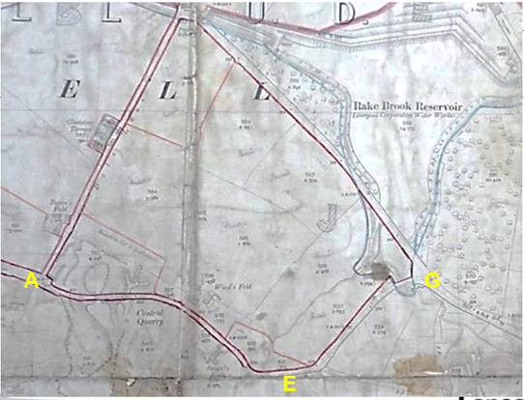
Observations |  | The Finance Act Map available to view at the National archives is incomplete. The first half of the route from point A to just west of point E is shown excluded and beyond that point a red line is shown drawn along the northern side of the route but not along the southern side. There are no plot numbers written on this part of the map indicating that it is incomplete.  No map has been deposited in the county records office for the area covering the application route.
Investigating Officer's Comments |  | The fact that part of the application route is shown excluded suggests that the route may have been considered as a public vehicular highway that should be exempted from the valuation process but the map is clearly incomplete so no clear inference can be drawn.
25 inch OS Map  Sheet LXX-14 | 1911 | Further edition of the 25 inch map surveyed in 1890-1891, revised in 1909 and published in 1911.
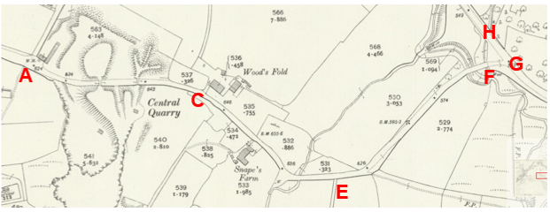
Observations |  | The application is again shown as a largely bounded through route with a thickened southern boundary but is not named on the map. The section between point F and point H is not shown.  The route provides access to and past a number of properties and is again shown passing through the middle of a quarry with bridges or tunnels shown to link across the route linking the two parts of the quarry.
Investigating Officer's Comments |  | The application route existed in 1909 and appeared to be wide enough for vehicular traffic and the thickened southern boundary indicates a well maintained carriageway.
25 Inch OS Map  Sheet LXX-14 | 1930 | Further edition of 25 inch map (surveyed in 1890-1891, revised in 1928 and published in 1930.
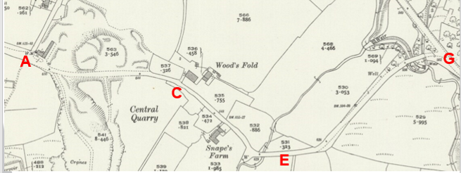
Observations |  | The application route is shown as a largely bounded through route but is not named on the map. The section between point F and point H is not shown.  The route provides access to and past properties named on the map and is still shown passing through the middle of the quarry.
Investigating Officer's Comments |  | The application route existed in 1928 and appeared to be wide enough for vehicular traffic. The route between point F and point H did not exist at that time.
Bartholomew's half inch map  Sheet 8 – Liverpool and Manchester | 1920 | Further edition of Bartholomew’s ½ inch mapping.
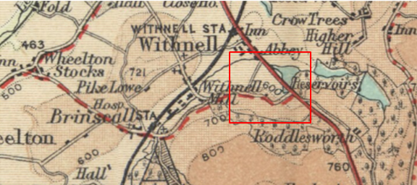
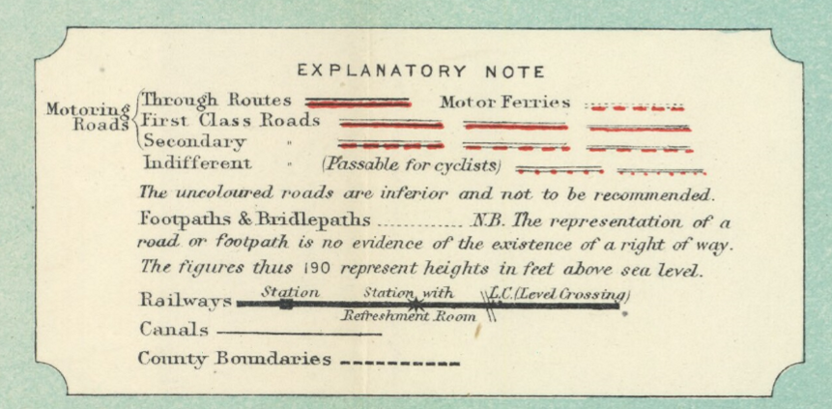
Observations |  | The application route is clearly shown and is marked on the map as being a second class motoring road.
Investigating Officer's Comments |  | The route still appeared to be considered as a public vehicular route suitable for motor vehicles in the 1920s.
Authentic Map Directory of South Lancashire by Geographia | Circa1934 | An independently produced A-Z atlas of Central and South Lancashire published to meet the demand for such a large-scale, detailed street map in the area. The Atlas consisted of a large-scale coloured street plan of South Lancashire and included a complete index to streets which includes every 'thoroughfare' named on the map.  The introduction to the atlas states that the publishers gratefully acknowledge the assistance of the various municipal and district surveyors who helped incorporate all new street and trunk roads. The scale selected had enabled them to name 'all but the small, less-important thoroughfares'.
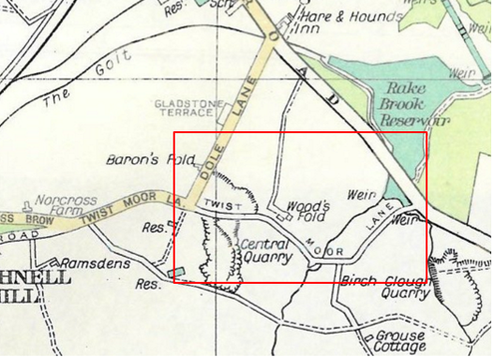
Observations |  | The application route is shown on the map as a through route named as Twist Moor Lane. It is shown uncoloured and narrower than the section of Twist Moor Lane west of point A. The colouring on the map indicates that the route primarily used by motor vehicles was that of Dole Lane.
Investigating Officer's Comments |  | The application route is shown in the atlas consistent with how other routes with proven as carrying public vehicular rights are shown. It is however depicted as being narrower than Twist Moor Lane west of point A and Dole Lane, which are shown coloured suggesting that by the 1930s the latter had now become the primary public vehicular route.
Aerial Photograph | 1940s | The earliest set of aerial photographs available was taken just after the Second World War in the 1940s and can be viewed on GIS. The clarity is generally very variable.
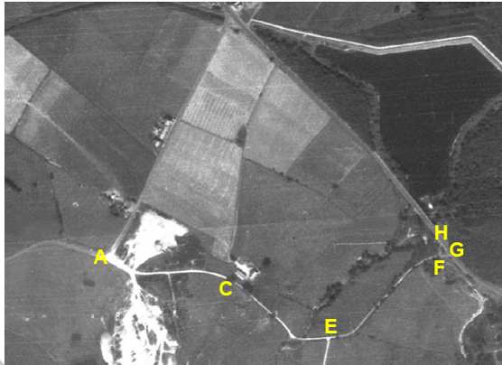
Observations |  | The full length of the application route can be very clearly seen from point A through to point G. The section between point F and point H can also be seen as a faint line.
Investigating Officer's Comments |  | The application route existed as a through route in the 1940s and the fact that it is so clearly shown is indicative of a significant amount of vehicular use throughout the full length. The route shows up on the photograph more clearly than Dole Lane suggesting that it was the more heavily used of the two routes. The quarry can also be clearly seen and it appears that material from the quarry was possibly taken from the site via point A but that it could also have been taken along the application route to point G.
1 inch OS Map  Sheet 94 - Preston | 1947 | Further small-scale OS map revised in 1920 with later corrections.
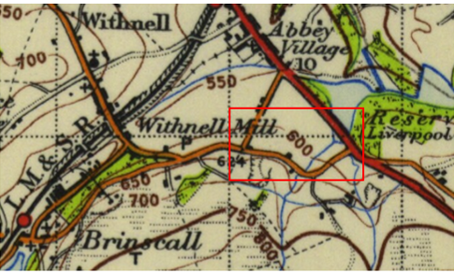
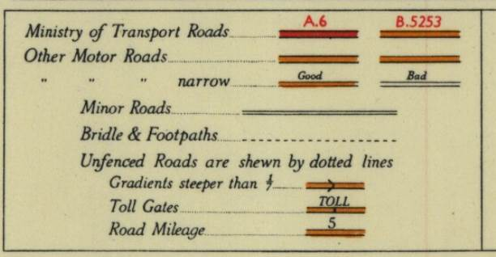
Observations |  | The application route is clearly shown and is marked on the map as a motoring road.
Investigating Officer’s Comments |  | The route still appeared to be considered as a public vehicular route suitable for motor vehicles on a small-scale OS map published in 1947.
6 Inch OS Map  Sheet 62SW | 1955 | The OS base map for the Definitive Map, First Review, was published in 1955 at a scale of 6 inches to 1 mile (1:10,560). This map was revised before 1930 and is probably based on the same survey as the 1930s 25-inch map.
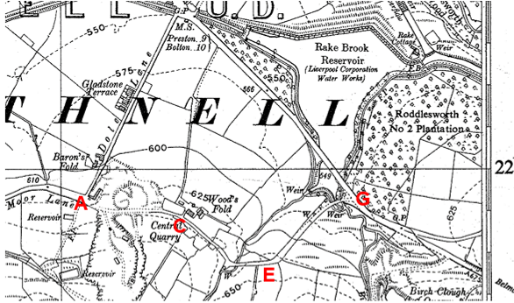
Observations |  | The application route is shown consistent with how it is shown on other OS maps of this scale.
Investigating Officer's Comments |  | The application route existed in the 1930s and appeared to be wide enough to be used by vehicles. The route between point F and point H did not exist at that time.
1:2500 OS Map  Sheet SD 6421 & 6521 | 1968 | Further edition of 25 inch map reconstituted from former county series and revised in 1968 and published the same year as part of the national grid series.
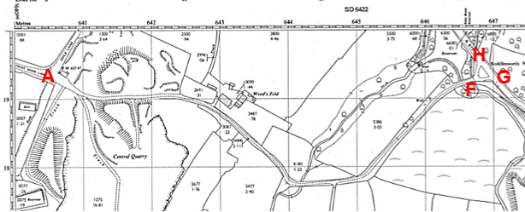
Observations |  | The application route can be clearly seen on the map with the full length open and accessible and not gated.  Solid boundaries are shown along much of the route – with the exception of the section passing through the quarry. Grass verges are indicated by pecked lines indicating the change from a solid road surface to grass for example.  This is the earliest map inspected to show the two separate routes leading out onto Bolton road – the earlier maps just showing the route between point F and point G whilst this map also shows the route between point F and point H.
Investigating Officer's Comments |  | The whole of the application route existed in 1968 as a substantial through route.
Aerial photograph | 1960s | The black and white aerial photograph taken in the 1960s and available to view on GIS.
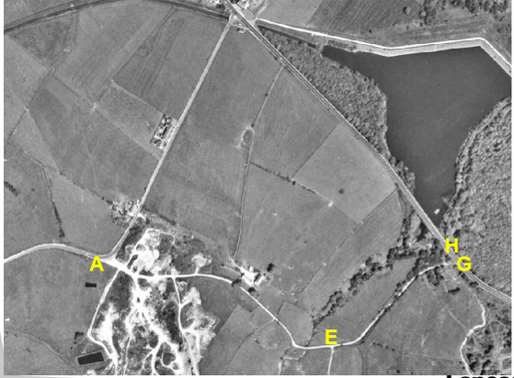
Observations |  | The full length of the application route can be very clearly seen from point A through to point G. The section between point F and point H can also be seen as a faint line.
Investigating Officer's Comments |  | The application route existed as a through route in the 1960s and the fact that it is so clearly shown is indicative of a significant amount of vehicular use throughout the full length. The quarry can also be clearly although it appears that quarrying may not have been as significant by the 1960s with areas of the quarry looking more vegetated than they did on the 1940s aerial photograph.
1 inch OS Map  Sheet 94 - Preston | 1961 | Small-scale OS map fully revised 1958 and published 1961.
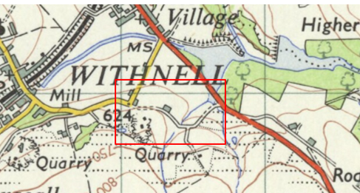
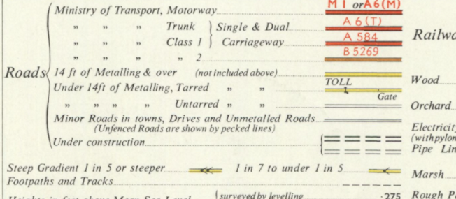
Observations |  | The application route is shown as an untarred road – partly unfenced in contrast to the earlier 1 inch map published in 1947 which showed it as more specifically as a motoring road.
Investigating Officer’s comments |  | The 1961 map shows that the application route still existed as a substantial route but significantly it makes a clear distinction between tarred and non tarred routes.  By the 1960s it may have been that because the application route was not tarred, use by public vehicles as a through route may have started to decline due to the fact that Dole Lane was recorded as having a better surface.
Aerial Photograph | 2000 | Aerial photograph available to view on Google Earth Pro
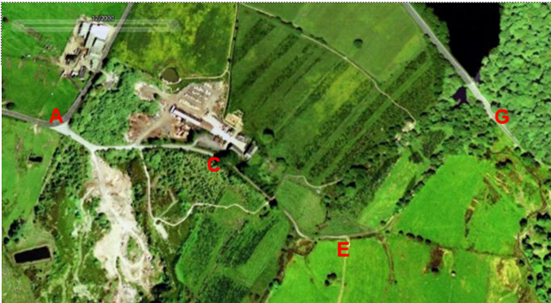
Observations |  | The application route can be clearly seen from point A though to the wood yard at point C. Beyond point C the route is still quite clearly visible through to point E but beyond point E only part of the route can be seen due to tree cover.
Investigating Officer’s Comments |  | The application route still appears to exist as a substantial route through to point C suggestive of a significant amount of vehicular use to access the former quarry site and the wood yard. Beyond point C the route can still be seen for part of the length although there appears to be much less evidence of use by vehicles.
Definitive Map Records |  | The National Parks and Access to the Countryside Act 1949 required the County Council to prepare a Definitive Map and Statement of Public Rights of Way.  Records were searched in the Lancashire Records Office to find any correspondence concerning the preparation of the Definitive Map in the early 1950s.
Parish Survey Map | 1950-1952 | The initial survey of public rights of way was carried out by the parish council in those areas formerly comprising a rural district council area and by an urban district or municipal borough council in their respective areas. Following completion of the survey the maps and schedules were submitted to the County Council. In the case of municipal boroughs and urban districts the map and schedule produced, was used, without alteration, as the Draft Map and Statement. In the case of parish council survey maps, the information contained therein was reproduced by the County Council on maps covering the whole of a rural district council area. Survey cards, often containing considerable detail exist for most parishes but not for unparished areas.
Observations |  | Withnell was an urban district council in the 1950s and no parish survey was carried out.
Draft Map |  | The Draft Maps were given a “relevant date” (1st January 1953) and notice was published that the draft map for Lancashire had been prepared. The draft map was placed on deposit for a minimum period of 4 months on 1st January 1955 for the public, including landowners, to inspect them and report any omissions or other mistakes. Hearings were held into these objections, and recommendations made to accept or reject them on the evidence presented.
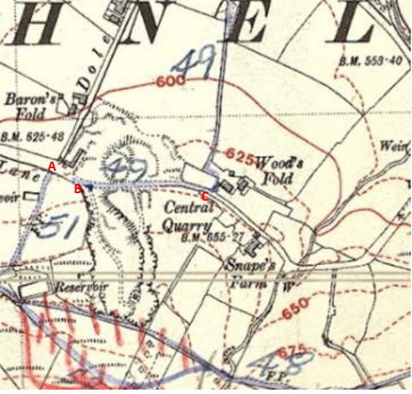
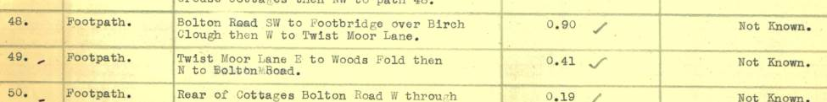
Observations |  | The application route was not recorded on the Draft Map for Withnell with the exception of the section between point B and point C which was included as part of Footpath 49 which was described as being from Twist Moor Lane east to Woods Fold and then north to Bolton Road.  No representations were made to the County Council about Footpath 49 or the application route.
Provisional Map |  | Once all representations relating to the publication of the draft map were resolved, the amended Draft Map became the Provisional Map which was published in 1960 and was available for 28 days for inspection. At this stage, only landowners, lessees and tenants could apply for amendments to the map, but the public could not. Objections by this stage had to be made to the Crown Court.
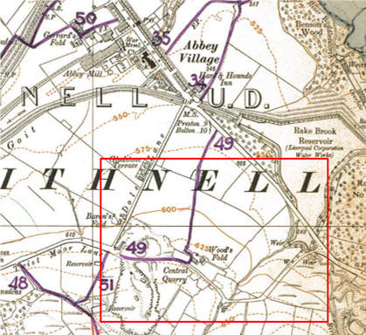
Observations |  | The application route between point A-B and from point C-F-G and F-H was not recorded on the Provisional Map. The application route between point B and point C was recorded as part of Footpath Withnell 49.
The First Definitive Map and Statement |  | The Provisional Map, as amended, was published as the Definitive Map in 1962.
Observations |  | The application route was not shown on the First Definitive Map other than the section between point B and point C which was recorded as part of Footpath Withnell 49.
Revised Definitive Map of Public Rights of Way (First Review) |  | Legislation required that the Definitive Map be reviewed, and legal changes such as diversion orders, extinguishment orders and creation orders be incorporated into a Definitive Map First Review. On 25th April 1975 (except in small areas of the County) the Revised Definitive Map of Public Rights of Way (First Review) was published with a relevant date of 1st September 1966. No further reviews of the Definitive Map have been carried out. However, since the coming into operation of the Wildlife and Countryside Act 1981, the Definitive Map has been subject to a continuous review process.
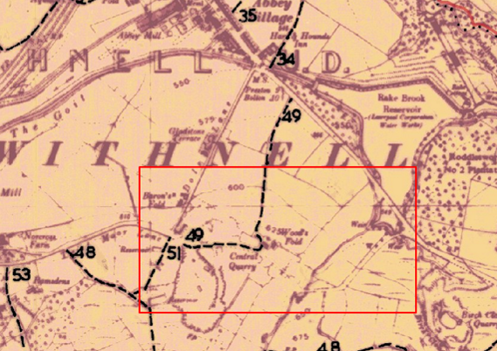
Observations |  | The application route is not recorded on the Revised Definitive Map (First Review) with the exception of that part between point B and point C on the Committee plan which is recorded as part of Footpath Withnell 49.
Investigating Officer's Comments |  | That part of the application route between point A and point B appears to have been considered to be part of the public vehicular highway recorded as Twist Moor Lane by Withnell UDC who only recorded the route of Footpath Withnell 49 as starting at point B on the Committee plan. Beyond point B to point C the application route was considered to be part of a longer footpath at that time and from point C onwards from 1953 through to 1975 there is no indication that the rest of the application route was considered to be a public right of way of the type to be recorded on the Definitive Map and Statement by the Surveying Authority. There were no objections or representations made with regard to what was shown when the maps were placed on deposit for inspection or at any stage of the preparation of the Definitive Map.
Highway Adoption Records including maps derived from the '1929 Handover Maps' | 1929 to present day | In 1929 the responsibility for district highways passed from rural district councils to the County Council. Withnell was an urban district so the 1929 handover did not include this area.  The County Council is now required to maintain, under section 31 of the Highways Act 1980, an up to date List of Streets showing which 'streets' are maintained at the public's expense. Whether a road is maintainable at public expense or not does not determine whether it is a highway or not.
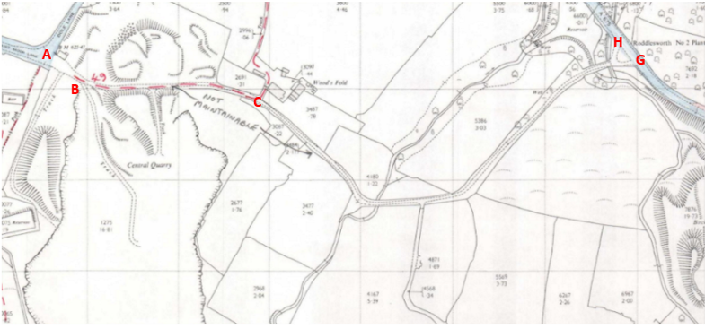
Extract from maps held by LCC Highways (map sheet SD 6421-6521)
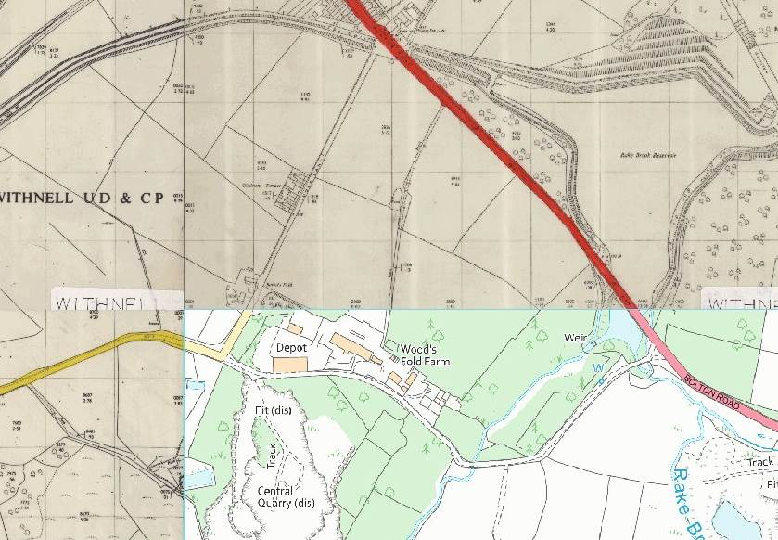
Scanned ‘adoption’ plans available to view on LCC Mapzone
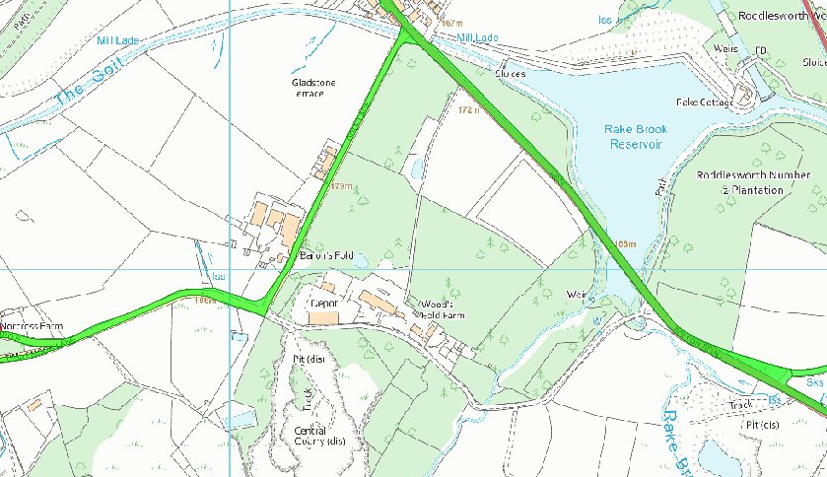
Digitised adoption layer on LCC Mapzone
Observations |  | The applicant lists the Handover Map as being one of the maps submitted in support of the application.  A search of our records confirms that the Handover Map sheet referred to by the applicant was the map prepared by Chorley Rural District (sheet 70SW) which was marked up by the rural district council. No routes were marked up within the area which was the responsibility of Withnell UDC at that time (including the land crossed by the application route). The base map used as the ‘Handover Map’ was the 6 inch OS sheet 70SW surveyed in 1844, revised 1909 and published in 1913. The applicant correctly makes the point that the application route was shown to exist on the base map.  A search of other records held by the county council with regards to public maintenance was made.  The application route is not recorded as a publicly maintainable highway on the county council's List of Streets.  The route between point B and point C is however publicly maintainable as a public footpath.  A handwritten note on a plan contained within the highway records for Chorley notes that neither the route of footpath Withnell 49 or the application route east of point C are maintainable at public expense but it is not known who wrote this comment or the basis for it’s inclusion on the map.
Investigating Officer's Comments |  | The fact that the route (with the exception of the route between point B and point C) is not recorded as a publicly maintainable highway does not mean that it does not carry public rights/additional rights of access.
Highway Stopping Up Orders | 1835 - 2014 | Details of diversion and stopping up orders made by the Justices of the Peace and later by the Magistrates Court are held at the County Records Office from 1835 through to the 1960s. Further records held at the County Records Office contain highway orders made by Districts and the County Council since that date.
Observations |  | No legal orders relating to the creation, diversion or extinguishment of public rights have been found.
Investigating Officer's Comments |  | If public rights are found to exist along the application route they do not appear to have been subsequently diverted or extinguished by a legal order.
Statutory deposit and declaration made under section 31(6) Highways Act 1980 |  | The owner of land may at any time deposit with the County Council a map and statement indicating what (if any) ways over the land he admits to having been dedicated as highways. A statutory declaration may then be made by that landowner or by his successors in title within ten years from the date of the deposit (or within ten years from the date on which any previous declaration was last lodged) affording protection to a landowner against a claim being made for a public right of way on the basis of future use (always provided that there is no other evidence of an intention to dedicate a public right of way).  Depositing a map, statement and declaration does not take away any rights which have already been established through past use. However, depositing the documents will immediately fix a point at which any unacknowledged rights are brought into question. The onus will then be on anyone claiming that a right of way exists to demonstrate that it has already been established. Under deemed statutory dedication the 20 year period would thus be counted back from the date of the declaration (or from any earlier act that effectively brought the status of the route into question).
Observations |  | No Highways Act 1980 Section 31(6) deposits have been lodged with the county council for the area over which the application route runs.
Investigating Officer's Comments |  | There is no intention by the landowners under this provision of non-intention to dedicate public rights of way over this land.

The affected land is not designated as access land under the Countryside and Rights of Way Act 2000 and is not registered common land.

Landownership

Between points A and D the application route crosses land owned by a local timber company. From point D the remainder of the route crosses land in the ownership of United Utilities.

The Natural Environment and Rural Communities Act 2006

This Act effected a blanket extinguishment of unrecorded public rights for mechanically propelled vehicles (MPVs) with certain exceptions. Prior to this carriageway rights did not discriminate between vehicles which were mechanically propelled, such as cars and motorbikes, and those which were not, such as bicycles, wheelbarrows, horse-drawn carriages, donkey carts, etc. If Committee concludes that the evidence shows that, on the balance of probability, public carriageway rights exist on the application route it is then necessary to consider whether the Natural Environment and Rural Communities Act 2006 has extinguished public rights for MPVs. The application route was, at the time of the act recorded as a public footpath between point B and point C on the Committee plan and was not on the List of Streets (maintained at public expenses) and it does not appear to have been used mainly by the public in MPVs. There is no claim that any other of the other exemptions apply. Therefore, in the event that public carriageway rights are shown to exist and the appropriate status for the application route to be recorded on the Definitive Map and Statement would be Restricted Byway, with public rights with non-mechanically propelled vehicles, horses or on foot.

Summary

It is rare to find one single piece of map or documentary evidence which is strong enough to conclude that public vehicular rights exist and it is often the case that we need to examine a body of evidence, often spanning a substantial period of time, from which public rights can be inferred. The comments below refer only to section A-G not F-H which is considered separately.

In this instance it appears that the route has existed as a substantial route since at least the late 1700s and was consistently shown on a series of early small scale commercial maps and the Tithe Map of 1840 suggesting that it was wide enough to be used by horse drawn vehicles at that time.

The early commercial maps and Tithe Map show it as being part of the route through Brinscall and Withnell through to Bolton Road (the former turnpike road) prior to the construction of Dole Lane in the mid to late 1840s and its depiction on these maps in such a way suggestive of public vehicular use.

The application route was shown on early Ordnance Survey maps with a thickened line to indicate a well-maintained carriage road.

Even after the construction of Dole Lane the application is still shown on all maps examined - including small scale maps published primarily for the motoring public – as a substantial route often clearly identified in map keys as being considered to be a public road. In addition it is consistently shown as an ungated through route passing through a working quarry – but quite clearly not diverted by the quarry – suggesting the importance of the route as one used by the public.

Use of the route by vehicles appears to have declined from the 1960s onwards – possibly due to the fact that it was not tarmacked and that it was more undulating and less direct than Dole Lane.

Since that time however, the route has still been used as access to the former quarry site and to the woodyard via point A although public vehicular access along the full length is restricted by gates at point D and between points F-G and F-H.

The route between point F and point H is not shown to exist on any maps examined until 1968 although the 1940s aerial photograph suggests that it may have existed at that time.

Head of Service – Legal and Democratic Services Observations

Information from the Applicant

The applicant provided extensive map and documentary evidence along with evidence forms detailing use of the route;

- OS 1” OS Maps 1809-1903.
- OS 25” England and Wales 1888-1913.
- OS 1:25,000 Maps of Great Britain 1937-1961.
- Bartholomews ½” to the mile England and Wales 1919-1924.
- Yates map of Lancashire 1786.
- Hennets map of Lancashire 1829.
- 1910 Inland Revenue Finance maps 1910.
- Handover maps 1929 Act.
- Mario extract.
- Land Registry documents.
- List of Streets extract.
- 8 user evidence forms.

The map evidence has been considered above, the 8 user evidence forms are summarised below.

Duration of Use

The user evidence forms collectively provide evidence of continuous use on foot going back as far as 1970 up to the present and use on horseback back to 1982 up to the submission of the application on 2nd July 2020. In addition, evidence of use on pedal cycle is recorded from 2003 to the present.

Frequency of Use

The majority of the 8 users stated that they used the route on a monthly basis or every few months.

Use on Foot
Monthly | Every Few Months | Yearly
1 | 2 | 1

Use on Horseback
Weekly | Monthly | Every Few Months
2 | 2 | 3

In addition, one user recorded use on pedal cycle every few months.

Details of Use

Of those who specified their reason for using the route, the most common answer was for pleasure or leisure.

All but one user recorded use on horseback with one noting the use of the route for organised rides as part of a longer circular route. Another noted that they used the route when on horseback to avoid busy traffic. One mentioned use of the route, as part of a longer route, to access the pony club and horse trainers.

Other Users of the Route

All users noted seeing others using the route, most noting use on horseback, 6 noting others using the route on foot and 6 recording others using the route on pedal cycle. 1 noted use of the route by farm tractors.

Consistency of the Route

All 8 users recorded that the route has always followed the same route.

Unobstructed Use of the Route

None of the 8 users recalled having been prevented from using the route.

4 acknowledge gates erected along the route, 2 users noting that there were erected in August 2018. 1 of these users only noted the installation of the gates, the remaining 3 went on to clarify that the gates did not cover the entire width of the route with gaps wide enough for horses and pedal cycles.

None of the 8 users recorded that they had been obstructed or turned back, nor did they record seeing any signs or notices deterring use.

2 users did record that another individual on horseback had been challenged several months before the application was made, being told that the route was not a bridleway.

Information from Others

Michael Prescott responded on behalf of Cyclist UK, he expressed support for the application and stated that he has cycled the whole length of Twist Moor Lane from the A675 to Dole Lane from 1996 to date.

Mr Prescott clarified that prior to the Turnpikes, Twist Moor Lane was the main road between Bolton and Preston, the higher route via Hoghton and Sharples and provided map extracts which have already been considered in this report. Mr Prescott also provided a photograph showing a section of the route, included below, captioned: 'This is the pre-turnpike road leading to the present day A675'

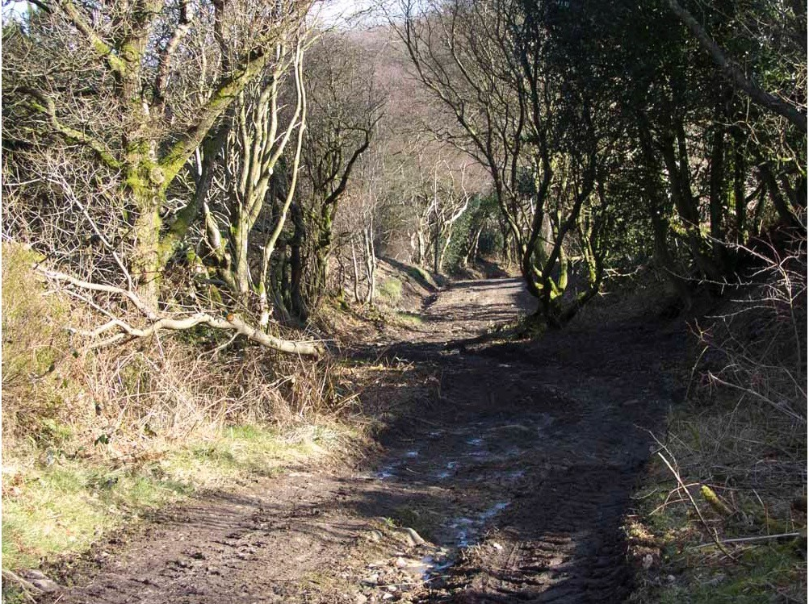

John Gardner, Rights of Road Officer, Lancashire Trail Riders Fellowship responded to our consultation stating that in his opinion the route already has a higher status as a public highway, stating that he has it marked as such on his personal OS map 103 Blackburn and Burnley. Mr Gardner stated that he first rode this route over 30 years ago and has ridden it a few times since then.

Atkins Global responded to our consultation with a qualified objection on the misunderstanding that this was a proposed stopping up order. A response correcting this misunderstanding was sent but no further communication has been received.

Information from the Landowner

No responses to our consultations have been received from the landowners.

Assessment of the Evidence

The Law - See Annex 'A'

In Support of Making an Order:

- Substantial map and documentary evidence supporting the physical existence of the route marked A-G as being a 'substantial route' capable of being used by horse drawn carriage since the late 1700s.
- With the exception of the two witnesses who refer to a horse rider having been turned away in recent times, there is an absence of action taken by landowners to prevent the use of the route.
- User evidence of long use on foot, horseback and pedal cycle.

Against Making an Order:

- The volume of user evidence is not substantial. NB this factor is only relevant where Committee are considering the weight to be attached to modern user evidence.

- Two witnesses refer to a horse rider having been 'turned away' whilst using the route in recent times.
- Gates have been erected in recent years at the western end of the route which may indicate a lack of intention to dedicate by landowners.

Conclusion

As there is no express dedication for the route, Committee is required to consider whether there is sufficient evidence from which a dedication of the route can be deemed under section 31 of the Highways Act 1980 and/or inferred at common law. In the case of that part of the route marked B-C, the Planning and Environment Group has investigated this route considering whether this section of footpath ought to be a highway of a different status, carrying higher public rights, namely the status of a restricted byway.

For both tests, there is a requirement for any public use of the route being considered to be 'as of right', which is interpreted as being use by the public that is
not by force, does not take place in secret and is not on the basis of permission of
any kind.

These conclusions seek to address routes A-G and F-H separately.

Route marked A-G
It is suggested that the Committee firstly consider the route A-G (being the application route) and consider the evidence to decide on balance the public rights dedicated thereon (if any) and then apply recent changes in the law under the Natural Environment and Rural Communities act 2006 (NERC Act).

Committee has to consider whether evidence from the old maps and other documentary evidence coupled with the evidence on site and the evidence of 8 users does, on balance, indicate how the route should be recorded. The analysis of the map and documentary evidence by the Planning and Environment Group strongly suggests that there is sufficient evidence on balance to indicate that this route was dedicated as a public carriageway and is recorded by the early mapmakers as such from as early as 1786 where the investigating officer comments that the route A-G "existed as a substantial route and appears to have formed a through route as part of the general road network.". It is therefore suggested that there are circumstances from which to infer an early dedication of the route marked A-G for use by the public. Being a substantial through route thought to be capable of accommodating horse and carriage, the evidence suggests that this route is a carriageway.

Consequently, the east-west route marked A-G should have historically been recorded as a byway open to all traffic however, due to the introduction of section 67 Natural Environment Rural Communities Act 2006 such recording is no longer possible. The implication of section 67(1) of the NERC Act is that because this route was 1) for the most-part not shown on the definitive map and statement and 2) with regards B-C, was shown on the definitive map and statement as a public footpath, any existing public rights of way for mechanically propelled vehicles have been extinguished. Consequently, the highest status that can be achieved by this route is that of a restricted byway.

It is noted that the user evidence indicates modern use on horseback and some cyclist use of route A-G but should committee be satisfied with the documentary evidence, it is suggested that this modern use would not bring about a dedication. Instead it is suggested that this is modern use of an old route dedicated many decades earlier.

If Committee does not consider there to be sufficient documentary evidence from which to infer early dedication, they will need to consider the user evidence and it is suggested that this may be sufficient from which to infer dedication of a bridleway in recent times from A-G.

Finally, with regards the imposition of gates at the western end, whilst this might be considered to indicate a lack of intention by the land owner, it is clear that the gates have been placed so as to leave a gap large enough for horse riders and suchlike to pass without restriction. It is suggested that the gates may have been placed to tackle anti-social behaviour including use of the route by unauthorised motor vehicles and not to hinder legitimate highway use. Further, if Committee agree that the map evidence indicates a historic dedication, the modern imposition of the gates would not undermine that earlier dedication.

In conclusion and consistent with the report recommendation, it is suggested that both the lower and higher tests can be met for the route marked A-G such that an order to that affect should be made and promoted to confirmation.

Route marked F-H
Considering that part of the route marked F-H, it appears that this length was laid out in the 1940s according to the aerial photograph and certainly that it was in existence by 1968 as can be seen by the 1968 OS map. It is clear that this length of the route is significantly more modern than A-G, which was shown on maps as early as 1786. This length of the route did not form part of the application and of the 8 user evidence forms submitted, none provide evidence of having used this part of the route.

Due to the lack of user evidence, at this time it is suggested that there is insufficient evidence of the use of this part of the route to satisfied that a right of way “subsists” or is “reasonably alleged to subsist” and further, that the higher confirmation test could be met at this time.

Risk management

Consideration has been given to the risk management implications associated with this claim. The Committee is advised that the decision taken must be based solely on the evidence contained within the report, and on the guidance contained both in the report and within Annex 'A' included in the Agenda Papers. Provided any decision is taken strictly in accordance with the above then there is no significant risks associated with the decision making process.

Local Government (Access to Information) Act 1985

List of Background Papers

Paper | Date | Contact/Directorate/Tel
All documents on File Ref: 804-648 |  | Simon Moore, 01772 531280, County Secretary and Solicitors Group
Reason for inclusion in Part II, if appropriate

N/A

The Ordnance Survey (OS) has produced topographic maps at different scales (historically one inch to one mile, six inches to one mile and 1:2500 scale which is approximately 25 inches to one mile). Ordnance Survey mapping began in Lancashire in the late 1830s with the 6-inch maps being published in the 1840s. The large scale 25-inch maps which were first published in the 1890s provide good evidence of the position of routes at the time of survey and of the position of buildings and other structures. They generally do not provide evidence of the legal status of routes, and carry a disclaimer that the depiction of a path or track is no evidence of the existence of a public right of way.
Aerial photographs can show the existence of paths and tracks, especially across open areas, and changes to buildings and field boundaries for example. Sometimes it is not possible to enlarge the photos and retain their clarity, and there can also be problems with trees and shadows obscuring relevant features.

